Space Missions Analysis Project

**Introduction:**

As a data analyst, I delved into the rich history of space missions from the 1950s to the present day. This project aimed to analyze and uncover trends in space launches, rocket usage, and the evolution of the space industry.

**Project Overview:**

The dataset encompassed 4,630 launches, offering insights into the success rates, rocket statuses, and the major players in space exploration.

**Key Findings:**

1. **Launch Statistics:**

* Total launches: 4,630
* Success rate: 90%
* Peak year: 2021 with the highest number of launches.

1. **Rocket Overview:**

* Total rockets: 370
* Retired rockets: 78%
* Active rockets: 22%

*Note: The retirement of rockets indicates the dynamic nature of space technology.*

1. **Top Rocket Providers:**

* Total rocket providers: 62
* Top 3 providers: RVSN USSR, CASC, and Arianespace.

**Data Insights:**

Understanding the success rates, the evolution of rocket technology, and the dominance of key players provides valuable insights into the trajectory of space exploration over the years.

**Visuals:**

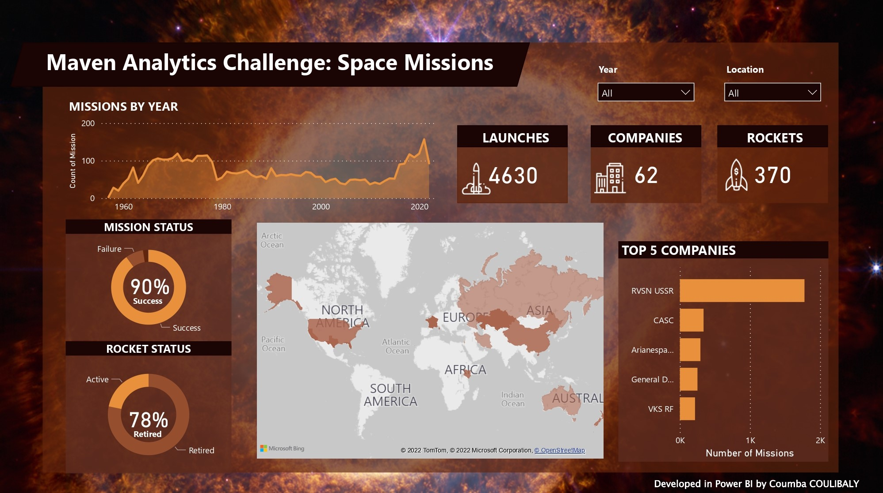

**Challenges:**

No significant challenges were encountered during the analysis, indicating the reliability of the dataset.

**Call-to-Action:**

For a more detailed exploration of space mission trends and statistics, refer to the comprehensive Space Missions Analysis Dashboard. [Link](https://drive.google.com/drive/folders/16rBfGB9x1GGC_rLli7N7QUpfagU7quGz?usp=drive_link)

**Contact Information:**

For inquiries or collaboration opportunities, please contact:

- Coumba COULIBALY

- Email: coumbacoulibaly09@gmail.com

- LinkedIn: [www.linkedin.com/in/coumba-coulibaly](http://www.linkedin.com/in/coumba-coulibaly)